**Name**: Hong Zhang

**Email Address**: hzhan121@hawk.iit.edu

**Class**: ITMD 562 -02

**Assignment 3**

**Project Description**: The assignment 3 is the extension of assignment 2 which uses SQlite to replace a txt file to store the data. This PHP application which includes 9 PHP files allows the user to log in the database, then create,edit, view, or delete a note in the database. Each note consists of Note ID, Note Subject, Author, Note Content, Total Note Characters and Create or Last Revise Time. The note data is stored in SQlite. When creating the object, the namespace is used to hold three files which are Note.php, INoteRepository.php and SQLiteNoteRepository.php.

**Development Environment:**

* Computer OS: Windows 8.1
* Local Server: XAMPP v3.2.1
* Editor: Sublime Text 3
* Internet

The login for Database:

* username: Hong
* Password: angel

**Installation Instruction:** The index.php is the entry point. This page will redirect to login.php and only show the log in page if the user have not logged in or typed in wrong username or wrong password. The user name is Hong and the password is angel. After the user log in the database, the index.php will show the notes list, let the useradd a new note or edit, delete a recorder in the notes list. Of course, the user can log out. The notes list include note subject, create or last revise time, total characters and the options to edit or delete this note. When the use wants to edit or delete a note, you can choose the buttons in the index.php or click the note subject which is a hyperlink to show the whole note and allow you to do these two options. When the use tries to delete the note, there will be a confirmation page before deletion.

**Insights and Results:**

**1. Open index.php**

**It will show login.php**

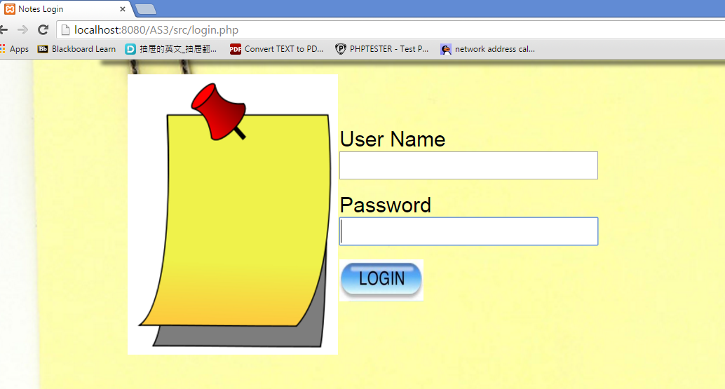

**If typing wrong username or password, it will show log in page again.**

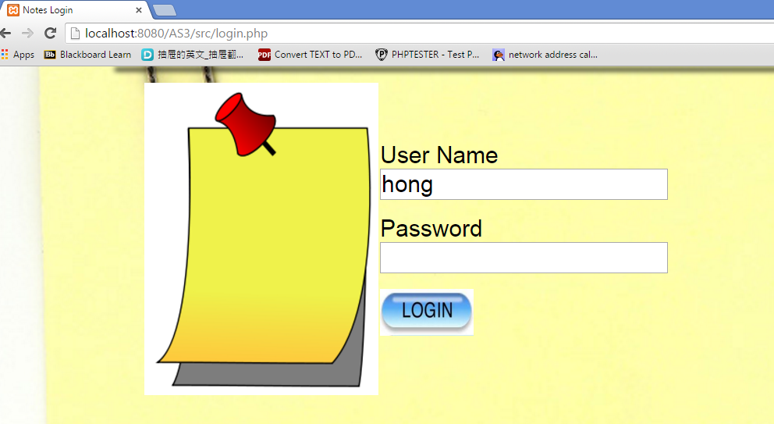

**This is the correct typing in the login page.**

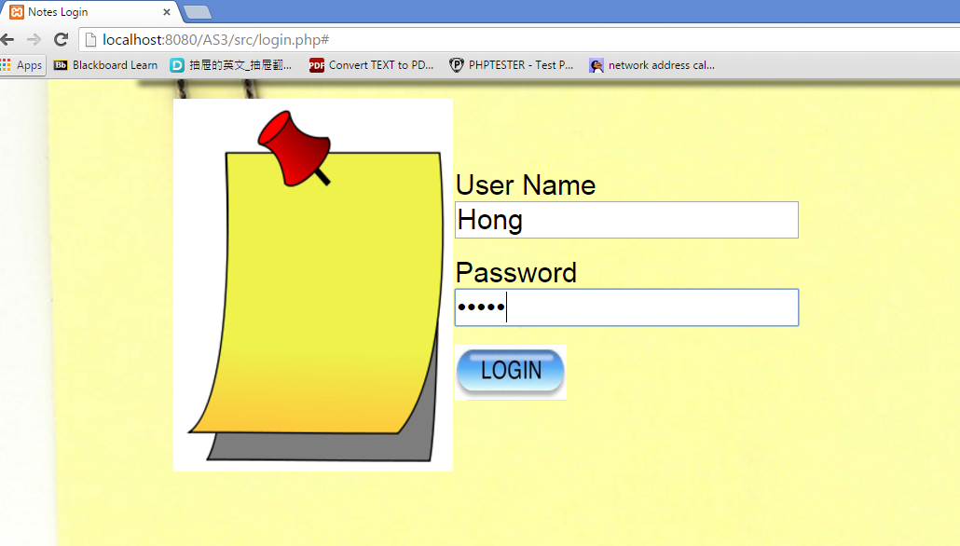

**If typing correct username and password, it will show the user’s notes list.**

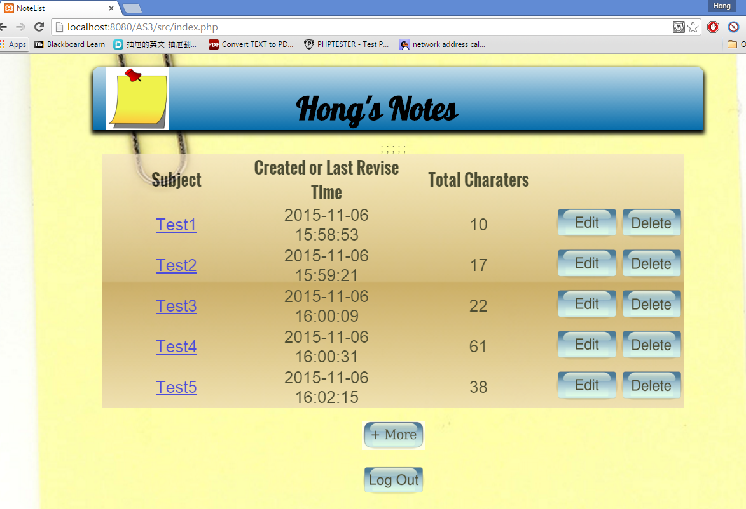

**If the user log out, the page will come back to login.php and show login again.**



**2. Add a new note which goes to create.php**



**Subject and author are required before saving a note. If not filling in these two fields, the page will show again.**



**Input will be checked and remove any whitespace or inject javacript.**

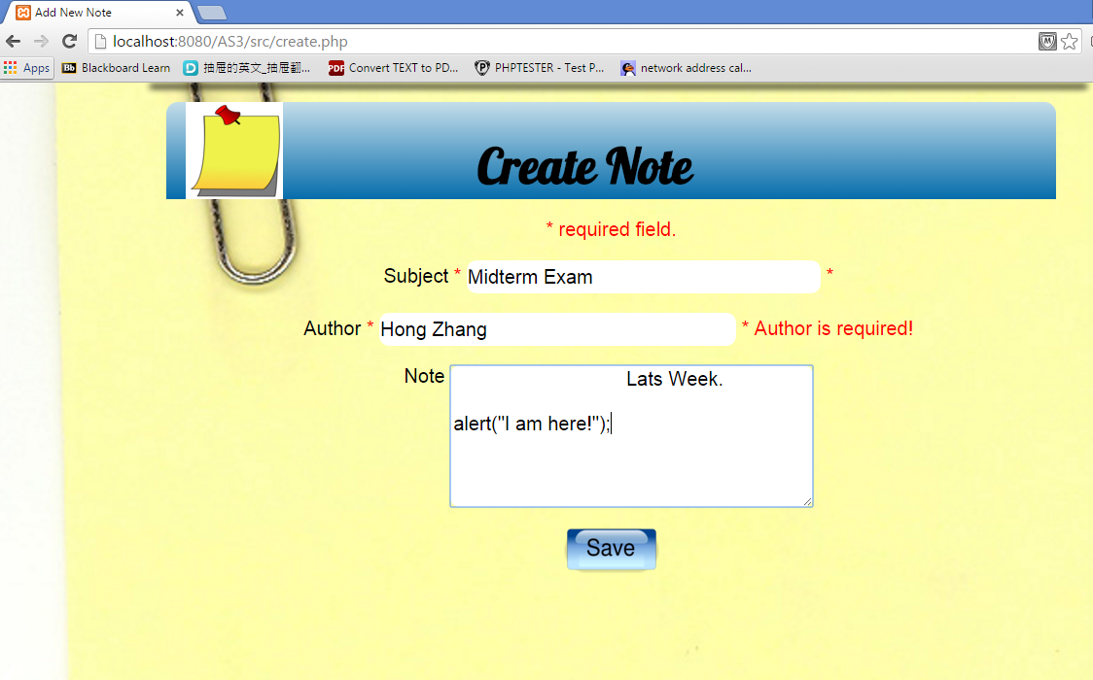

**After checking the validation, save the data to note_db_pdo.sqlite and show the result.**

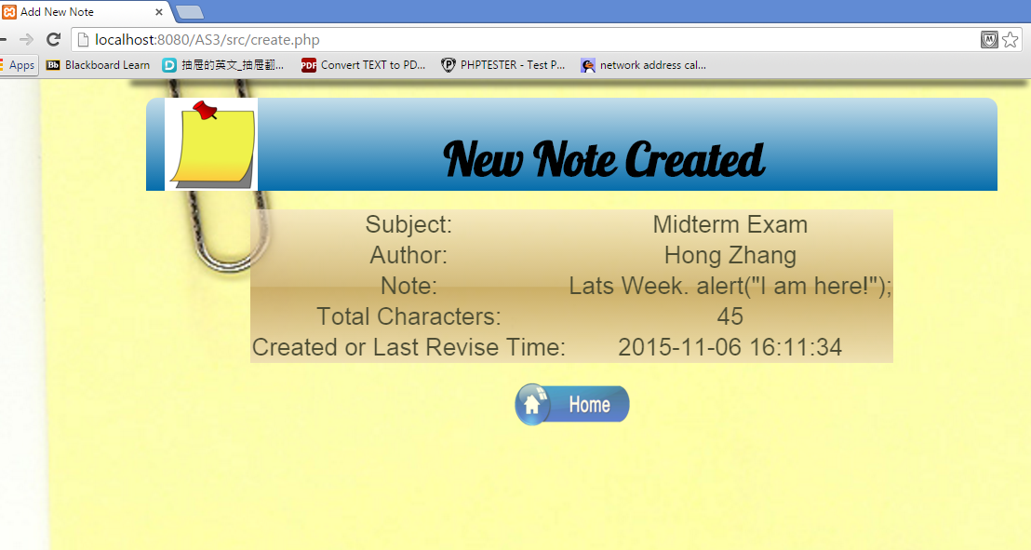

**Then, the user can go back to home page, index.php and find the new note.**

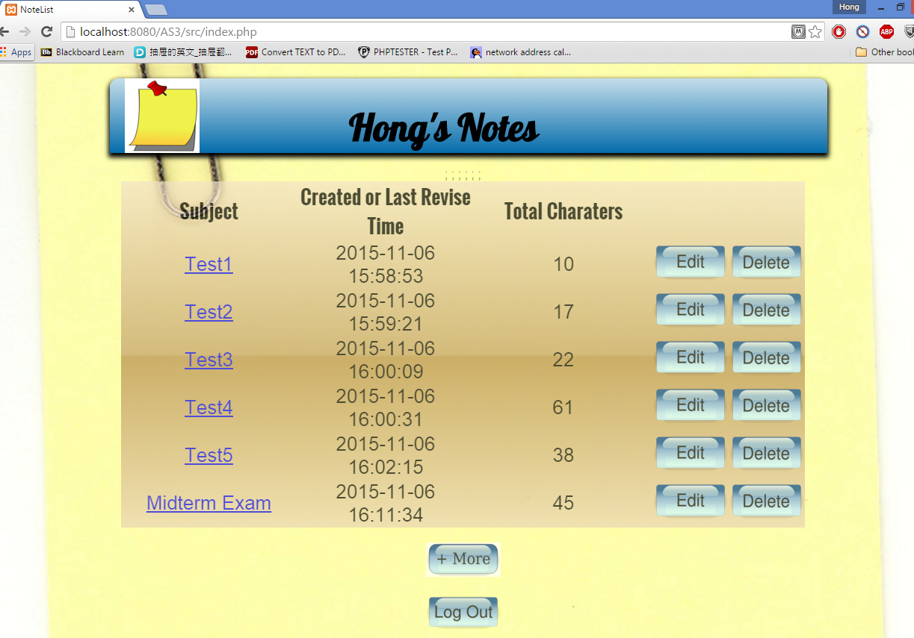

**3. Show Note in show.php.**

**Click the note subject which is a hyperlink to show the whole note.**

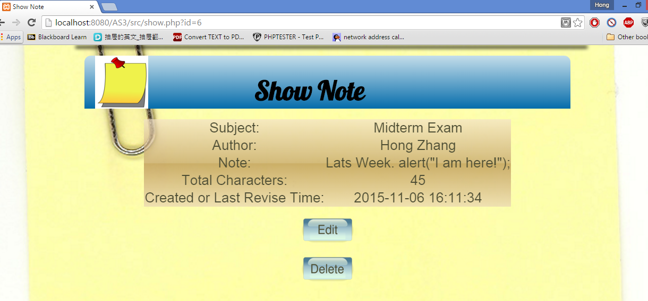

**If just open directly show.php without the ID parameter, there is no note to show.**



**4. Edit a note in edit.php**

**The user can click the edit button in index page or show page to edit the note. After updating, user can go back the home page.**

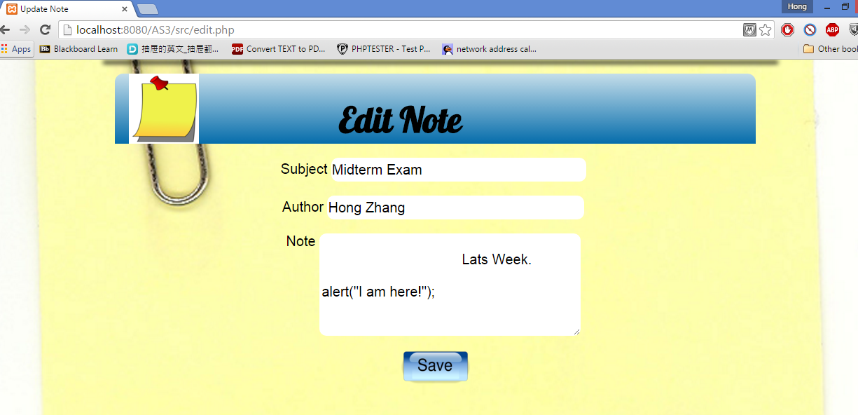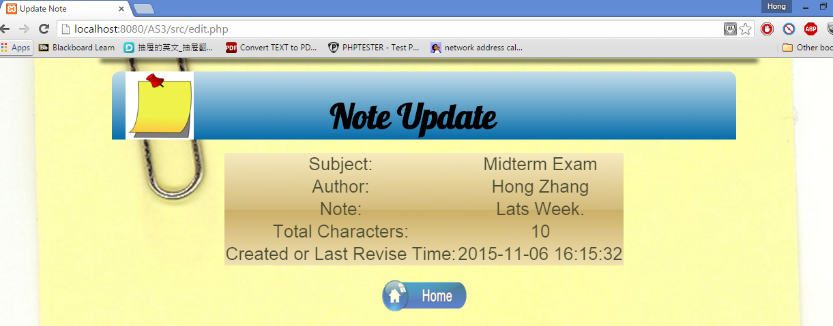

**If just open directly edit.php without the ID parameter, there is no note need to be edited.**



**5. Delete a note in delete.php**

**User can choose delete button in home page or show page to delete a note. Before deleting this note, there will show the note information and confirm the user’s deleting requirement.**

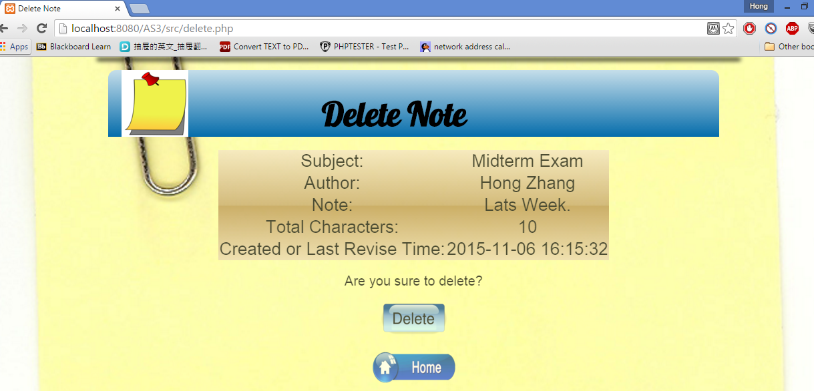

**After confirming, the note will be deleted.** 

**User can come back to home page to check it.**

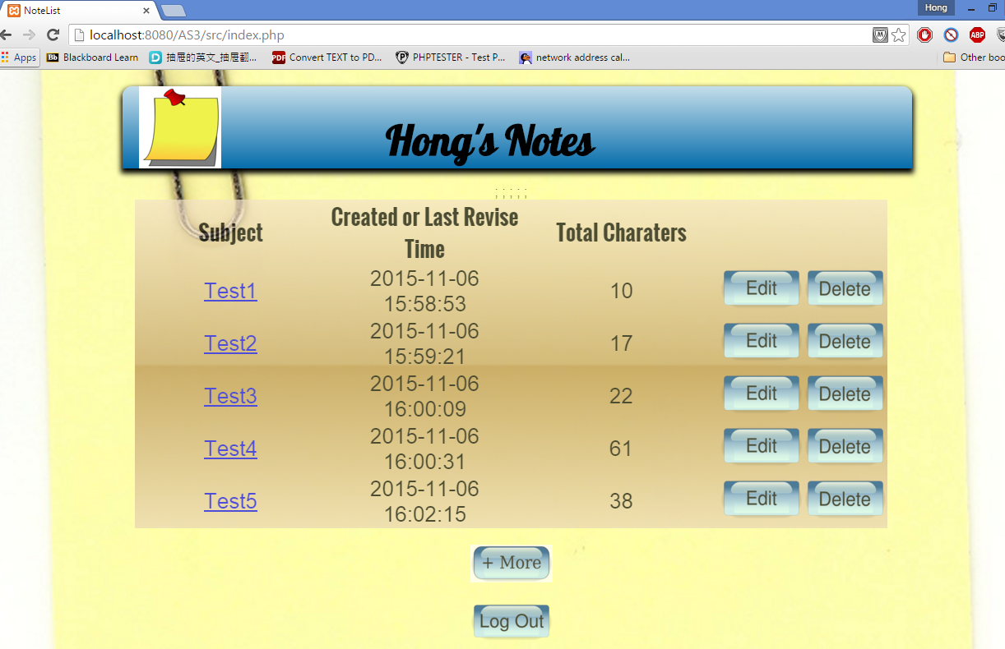

If just open directly delete.php without the ID parameter, there is no note need to be deleted.

